**MINISTRY OF EDUCATION AND TRAINING**

**HCMC UNIVERSITY OF TECHNOLOGY AND EDUCATION**

**FACULTY FOR HIGH-QUALITY TRAINING**



Final Project

Fast-food Restaurant Management

Course: Database Management system

Lecturer: Nguyen Thanh Son

**Group 8:**

|  |  |
| --- | --- |
| **Name** | **ID** |
| Vũ Hoàng Trúc Vy | 20110415 |
| Nguyễn Việt Anh | 20110352 |
| Lý Hồng Khanh | 20110373 |

*HCMC Feb, 2022*

**SCORE**

# **REMARKS**

………………………………………………………………………………………………………………………………………………………………….……………….……………….……………….…………

………………………………………………………………………………………………………………………………………………………………………………………………………………………………

………………………………………………………………………………………………………………………………………………………………………………………………………………………………

………………………………………………………………………………………………………………………………………………………………………………………………………………………………

………………………………………………………………………………………………………………………………………………………………………………………………………………………………………………………………………………………………………………………………………………

Ho Chi Minh City, February, 2022

Teacher’s score

(Signature)

# **THANK YOU**

In order to successfully complete this topic and this report, we would like to extend our sincere thanks to the lecturer, Dr. Nguyen Thanh Son, who directly supported us throughout the process of making the topic. We thank the teacher for giving advice from his practical experience to guide us in the right direction with the requirements of the selected topic, always answer questions and give suggestions and corrections. time to help us overcome our shortcomings and complete it well as well as on schedule.

We also would like to express our sincere thanks to the teachers in the

High Quality Education Department in general and the Information Technology industry in particular for their dedicated knowledge to help us have a foundation to make. This topic has created conditions for us to learn and perform well on the topic. Along with that, we would like to thank our classmates for providing useful information and knowledge to help us improve our topic.

The topic and report are made by us in a short time, with limited knowledge and many other limitations in terms of technical and experience in implementing a software project. Therefore, in the process of creating a topic with shortcomings is inevitable, we look forward to receiving valuable comments from the teachers to make our knowledge more complete and We can do even better next time.

We sincerely thank you.

At the end, we would like to wish all of you teachers, ladies and gentlemen, always having abundant health and more success in the career of growing people. Once again, we sincerely thanks.

Mục lục

**REMARKS** 2

**THANK YOU** 3

**I. PROJECT SPECIFICATION** 1

**1. Data used in the project.** 1

**2. Function required** 1

**II. DESIGN DATABASE** 2

**1.** **Design database with conceptual level: ERD** 2

**2. Design database with logical level** 3

**3. Describe the meaning of the above relations and constraints** 3

**4. Decribe procedure functions in the project:** 3

**5. Grant user** 8

**6. Function** 9

**7. View** 11

# **I. PROJECT SPECIFICATION**

## **1. Data used in the project.**

The restaurant needs to manage the food sale, price and revenue every day.

This restaurant has many staffs. Each employee has an individual ID, name, phone number, salary and type of staff (manager or employee).

The restaurant has a menu, each dish has a private dish ID, dish name, price and status indicating the number of dish remaining.

Each customer information will be saved for convenient delivery if they have a need or want to calculate the bill. Each customer has customer ID, name, address, phone number for delivery/contact or return the bill.

Customers visit the restaurant for order, the restaurant will record the list of ordered dishes with information: Bill ID, Dish ID, Number of dishes, Price When the customers choose a dish, they need to choose/update that dish quantity in menu.

After listing the odered dishes, it will calculate the Bill: Bill ID, Total Price and Date.

There is a discount voucher 5% for customers that order dish with the total bill from 1M above.

## **2. Function required**

The system will calculate the customer bill base on ID and date, displays dish ID, dish name, quantity, price and ordered date, total bill and discount voucher (if any).

* Calculate employee salary
* Refresh price and dish status.
* Calculate revenue for date X: summary of price having date X.
* Count the number of guests that have come on date X.
* Search guest by Name or ID then print out the list of buying dishes.
* Find guest bring the most/lowest profit.
* Sort the list of dishes(menu) by lower price or higher price.
* Sort the list of dishes(menu) based on hot selling.
* Add/Remove a dish from the list.
* Add/Remove a guest from the list.
* Suggest dishes based on guest’s buying history.

# **II. DESIGN DATABASE**

## **Design database with conceptual level: ERD**

## 

## **2. Design database with logical level**

**Customer** *(Cus_ID, Cus_Name, Cus_Phone_Number, Cus_Address)*

**Staff** *(ID, Staff_Name, Phone_Number, Salary, Type)*

**Menu** *(Dish_ID, Dish_Name, Price, Dish_Status)*

**Bill** *(Bill_ID, Total_Price, Sold_Date)*

**Bill_Detail** *(Bill_ID, Dish_ID, Dish_Num,Price)*

**Delivery** *(Bill_ID, Cus_Address, Delivery_Date)*

## **3. Describe the meaning of the above relations and constraints**

|  |  |
| --- | --- |
| Table Name | Target |
| Customer | Contain personal information of customer Cus_ID is primary key |
| Staff | Contain personal information of employee.  ID is primary key |
| Menu | Contain list of dishes.  Dish_ID is primary key |
| Bill | Contain the total price that customer should pay, the date they buy.  Bill_ID is primary key |
| Bill_Detail | Listing all dishes that customer ordered.  Bill_ID, Dish ID is primary key.  Each bill will contain many dishes  Each dish can be bought more than 1 |
| Delivery | Contain customer address  Bill_ID is foreign key referencing to Bill_ID of table Bill  Each bill can be delivered once |

## **4. Decribe procedure functions in the project:**

|  |  |
| --- | --- |
| Procedure | Target |
| Add_Employee | Add staff |
| Remove_Employee | Remove staff  from Staff table |
| Update_Employee | Edit staff infomation |
| Update_DishStatus | Check if the dish is avalable or not |
| Update_Price | Edit new price for dishs |
| Calculate_DateRevenue | Calculate the revenue in a day |
| List_dish | List all dish that the customer ordered |
| FindGuest_TheMostProfit | Find the customer with the highest bill |
| SortPrice_lowtohigh | Sort dish price from low to high |
| SortPrice_hightolow | Sort dish price from high to low |
|  |  |

Decribe triggers in the project:

* Insert dish’s status into Bill_Detail table

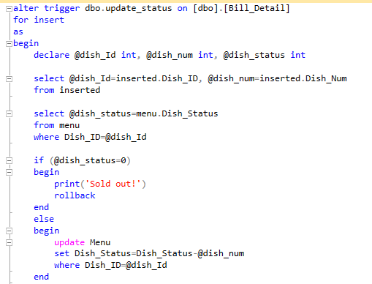

* Give discount of 5% if the total price is 1000 or above

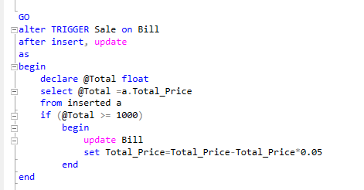

## **5. Grant user**

* Admin:
  + User Name: Admin_Login
  + Password: 1
  + Has all rights to work with database
* Employee:
  + User Name: Test_Login1
  + Password: 123
  + Employee has right to select the Staff table
* Grant Staff

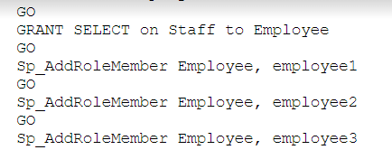

* Customer:
  + User Name: Cus1
  + Password: cus1
  + Customer has rights to select Bill, Bill_Detail, Menu table.
* Grant Customers:

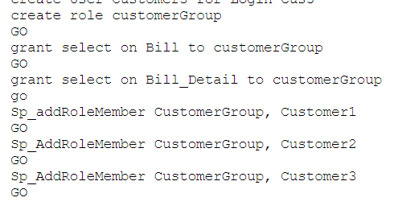

## **6. Function**

Count Guest:

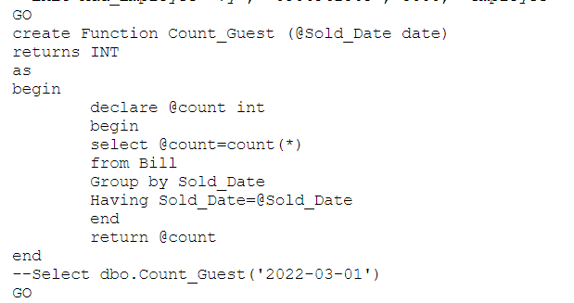

Get Guest Information:

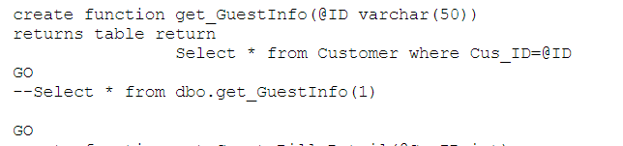

Get Guest Bill Detail:

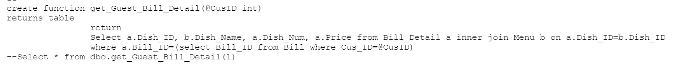

## **7. View**

